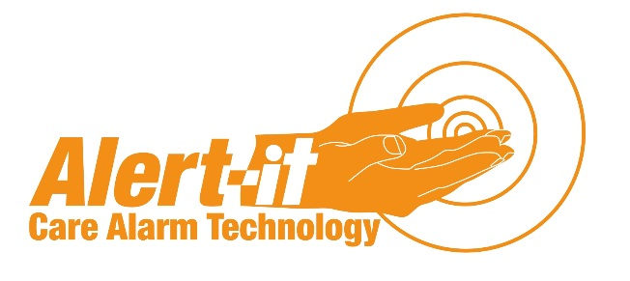

Competition Form
Please simply complete and submit to sales@alert-it.co.uk or return by post to the address below.
Contact Details
Alert-iT Care Alarms, Atherstone House, Merry Lees Industrial Estate, Desford, Leicestershire, LE9 9FE
0845 217 9951 or 01530 231215
Name:
Address:

Telephone:

The Companion Mini has been designed to support people with Tonic-Clonic seizures. Please confirm that this will be a suitable monitor by ticking the adjacent box. If you are unsure of its suitability please give us a call.
By submitting this form you are consenting to Alert-iT publishing the successful entries and requesting feedback. The list of recipients will be posted on the Alert-iT blog.
Alert-iT will not use the individual’s details for any other purpose or pass them on to any 3rd parties.
Any unsuccessful nominations will be offered 30% discount if they choose to purchase the product.

